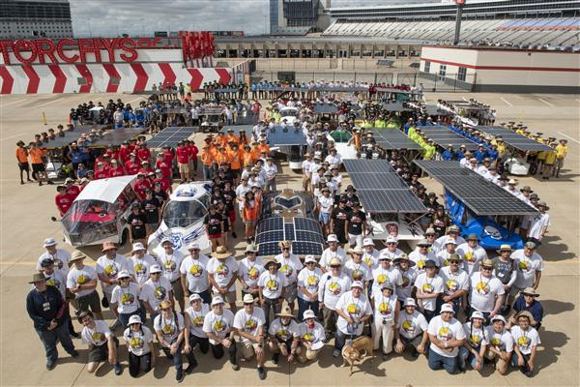
THE NATURE OF THE COMPETITION

Goal of the Solar Car Challenge
The Solar Car Challenge is designed to help motivate students in Science, Engineering, and Alternative Energy. The SCC Education Program supports this goal by teaching high school students how to plan, design, engineer, build, test, and safely drive a roadworthy solar car. This is accomplished through hands-on workshops, virtual learning opportunities, curriculum materials, on-site visits, and mentors. We are building the Engineers and Innovators of the future.

Event Objective
Teams experience the fun of the 2024 Solar Car Challenge by driving four days at the world famous Texas Motor Speedway. Car breakdowns, variations in weather, track conditions, and team experience limit the number of miles a team can drive each day. The team driving the most miles accumulated over the 4 days of the event will be declared the winner in each racing division.

Solar Car Categories
The purpose of the Solar Car Challenge is to provide a level playing-field for high school solar car teams. Newer teams generally enter the Classic Division which requires participants to use less expensive conventional motors, Lead Acid batteries, and less efficient solar cells. Older teams enter the Advanced Division based on their use of more expensive technologies, advanced aerodynamic bodies, and exotic batteries. The Electric-Solar Powered Division seeks to bring reality to solar car racing by incorporating a stationary solar array, and a two-passenger vehicle capable of urban driving. The new Cruiser Division brings a four-passenger vehicle to the competition with solar cells incorporated into the body of the car.

Admission into the Race
Teams seeking admission to the event must demonstrate their solar car complies with all the rules during a qualifying process known as “Scrutineering.” Race Officials want to see that participants understand their mechanical and electrical designs, and are capable of discussing their work in an oral presentation before a panel of judges.

Safety & Supervision
Each car must have a roll cage, “crush zones,” safety harness, horn, communications, turn signals, and a fire extinguisher. Chase vehicles and trailers are available for support in the event of a breakdown on the track. All aspects of the Solar Car Challenge Rules are closely monitored.

